As filed with the Securities and Exchange Commission on August 3, 2017

Registration No. 333-

UNITED STATES

SECURITIES AND EXCHANGE COMMISSION

Washington, D.C. 20549

FORM S-8

REGISTRATION STATEMENT

UNDER

THE SECURITIES ACT OF 1933

FLUIDIGM CORPORATION

(Exact name of Registrant as specified in its charter)

Delaware | 77-0513190
(State or other jurisdiction of |  |  | (I.R.S. Employer
incorporation or organization) |  |  | Identification No.)
 |  | 7000 Shoreline Court, Suite 100
 | South San Francisco, California 94080
 | (650) 266-6000
 | (Address of principal executive offices, including zip code)
 | Fluidigm Corporation 2017 Employee Stock Purchase Plan
 |  | (Full title of the plan)
 |  | Stephen Christopher Linthwaite
 | President and Chief Executive Officer
 |  | 7000 Shoreline Court, Suite 100
 | South San Francisco, California 94080
 | (650) 266-6000
 | (Name, address and telephone number, including area code, of agent for service)
 |  | Copies to:
 |  | Nicholas Khadder
 |  | General Counsel
 |  | 7000 Shoreline Court, Suite 100
 | South San Francisco, California 94080
 |  | Telephone: (650) 266-6000
 |  | Robert F. Kornegay
 |  | Wilson Sonsini Goodrich & Rosati,
 |  | Professional Corporation
 |  | 650 Page Mill Road
 |  | Palo Alto, California 94304
 |  | Telephone: (650) 493-9300

Indicate by check mark whether the registrant is a large accelerated filer, an accelerated filer, a non-accelerated filer, a smaller reporting company, or an emerging growth company. See the definitions of “large accelerated filer,” “accelerated filer,” “smaller reporting company,” and “emerging growth company” in Rule 12b-2 of the Exchange Act.

Large accelerated filer | ☐ | Accelerated filer | x
Non-accelerated filer | ☐ (Do not check if a smaller reporting company) | Smaller reporting company | ☐
 |  | Emerging growth company | ☐

If an emerging growth company, indicate by check mark if the registrant has elected not to use the extended transition period for complying with any new or revised financial accounting standards provided pursuant to Section 7(a)(2)(B) of the Securities Act. ☐

CALCULATION OF REGISTRATION FEE

Title of Securities to be Registered

Common Stock, $0.001 par value per share, reserved for issuance pursuant to the Fluidigm Corporation 2017 Employee Stock Purchase Plan

TOTAL:

Amount |  | Proposed |  | Proposed |  | Amount of
 |  | Maximum Offering |  | Maximum Aggregate |  | Amount of
to be Registered⁽¹⁾ |  | Price Per Share |  | Offering Price |  | Registration Fee

1,000,000 |  | $ |  | 3.28⁽²⁾ |  | $ |  | 3,280,000.00 |  | $ | 380.15
1,000,000 |  |  |  |  |  |  | $ | 3,280,000.00 |  | $ | 380.15

- Pursuant to Rule 416(a) of the Securities Act of 1933, as amended, this Registration Statement shall also cover any additional shares of the Registrant’s common stock that become issuable under the Fluidigm Corporation 2017 Employee Stock Purchase Plan (the “2017 ESPP”) by reason of any stock

dividend, stock split, recapitalization or other similar transaction effected without receipt of consideration that increases the number of the Registrant’s outstanding shares of common stock.

- Estimated in accordance with Rule 457(h) solely for the purpose of calculating the total registration fee. Computation based upon 85% (see explanation in following sentence) of $3.85, the average of the high and low prices of the Registrant’s common stock as reported on the Nasdaq Global Select Market on July 28, 2017. Pursuant to the 2017 ESPP, the purchase price of the shares of common stock reserved for issuance thereunder will be 85% of the lower of the fair market value of the common stock on (i) the first trading day of the offering period or (ii) the exercise date.

FLUIDIGM CORPORATION

EXPLANATORY NOTE

This Registration Statement is filed by Fluidigm Corporation (the “Registrant”) for the purpose of registering 1,000,000 shares of common stock of the Registrant that are currently reserved for issuance under the Fluidigm Corporation 2017 Employee Stock Purchase Plan.

PART I

INFORMATION REQUIRED IN THE PROSPECTUS

The information specified in Item 1 and Item 2 of Part I of Form S-8 is omitted from this Registration Statement on Form S-8 (the “Registration Statement”) in accordance with the provisions of Rule 428 under the Securities Act of 1933, as amended (the “Securities Act”), and the introductory note to Part I of Form S-8. The documents containing the information specified in Part I of Form S-8 will be delivered to the participants in the equity benefit plan covered by this Registration Statement as specified by Rule 428(b)(1) under the Securities Act.

PART II

INFORMATION REQUIRED IN REGISTRATION STATEMENT

Item 3. Incorporation of Documents by Reference.

The Registrant hereby incorporates by reference into this Registration Statement the following documents previously filed with the Commission:

- The Registrant’s Annual Report on Form 10-K for the fiscal year ended December 31, 2016, filed with the Commission on March 3, 2017 and the Registrant’s Amendment No. 1 to the Registrant’s Form 10-K, filed with the Commission on April 28, 2017;

- The Registrant’s Quarterly Report on Form 10-Q for the three months ended March 31, 2017, filed with the Commission on May 9, 2017;

- The Registrant’s Current Reports on Form 8-K filed with the Commission on January 11, 2017, February 10, 2017, March 2, 2017, March 27, 2017, May 24, 2017, August 2, 2017, August 2, 2017, August 3, 2017, and August 3, 2017 only to the extent that the items therein are specifically stated to be “filed” rather than “furnished” for the purposes of Section 18 of the Securities Exchange Act of 1934, as amended (the “Exchange Act”); and

- The description of the Registrant’s common stock contained in the Company’s Registration Statements on Form 8-A (File No. 001-34180) filed with the Commission on February 7, 2011, pursuant to Section 12(b) of the Exchange Act, including any amendment or report filed for the purpose of updating such description.

All documents filed by the Registrant pursuant to Sections 13(a), 13(c), 14 and 15(d) of the Exchange Act on or after the date of this Registration Statement and prior to the filing of a post-effective amendment to this Registration Statement that indicates that all securities offered have been sold or that deregisters all securities then remaining unsold shall be deemed to be incorporated by reference in this Registration Statement and to be part hereof from the date of filing of such documents; provided, however, that documents or information deemed to have been furnished and not filed in accordance with the rules of the Commission shall not be deemed incorporated by reference into this Registration Statement. Any statement contained in a document incorporated or deemed to be incorporated by reference herein shall be deemed to be modified or superseded for purposes of this Registration Statement to the extent that a statement contained herein or in any subsequently filed document which also is deemed to be incorporated by reference herein modifies or supersedes such statement. Any such statement so modified or superseded shall not be deemed, except as so modified or superseded, to constitute a part of this Registration Statement.

Under no circumstances will any information furnished under current items 2.02 or 7.01 of Form 8-K be deemed incorporated herein by reference unless such Form 8-K expressly provides to the contrary.

Item 4. Description of Securities.

Not applicable.

Item 5. Interests of Named Experts and Counsel.

Not applicable.

Item 6. Indemnification of Directors and Officers.

Section 145 of the Delaware General Corporation Law authorizes a corporation’s board of directors to grant, and authorizes a court to award, indemnity to officers, directors, and other corporate agents.

As permitted by Section 102(b)(7) of the Delaware General Corporation Law, the Registrant’s certificate of incorporation includes provisions that eliminate the personal liability of its directors and officers for monetary damages for breach of their fiduciary duty as directors and officers.

In addition, as permitted by Section 145 of the Delaware General Corporation Law, the bylaws of the Registrant provide that:

- The Registrant shall indemnify its directors and officers for serving the Registrant in those capacities or for serving other business enterprises at the Registrant’s request, to the fullest extent permitted by Delaware law. Delaware law provides that a corporation may indemnify such person if such person acted in good faith and in a manner such person reasonably believed to be in or not opposed to the best interests of the Registrant and, with respect to any criminal proceeding, had no reasonable cause to believe such person’s conduct was unlawful.

- The Registrant may, in its discretion, indemnify employees and agents in those circumstances where indemnification is not required by law.

- The Registrant is required to advance expenses, as incurred, to its directors and officers in connection with defending a proceeding, except that such director or officer shall undertake to repay such advances if it is ultimately determined that such person is not entitled to indemnification.

- The Registrant will not be obligated pursuant to the bylaws to indemnify a person with respect to proceedings initiated by that person, except with respect to proceedings authorized by the Registrant’s board of directors or brought to enforce a right to indemnification.

- The rights conferred in the bylaws are not exclusive, and the Registrant is authorized to enter into indemnification agreements with its directors, officers, employees, and agents and to obtain insurance to indemnify such persons.

- The Registrant may not retroactively amend the bylaw provisions to reduce its indemnification obligations to directors, officers, employees, and agents.

The Registrant’s policy is to enter into separate indemnification agreements with each of its directors and officers that provide the maximum indemnity allowed to directors and executive officers by Section 145 of the Delaware General Corporation Law and also provides for certain additional procedural protections. The Registrant also maintains directors and officers insurance to insure such persons against certain liabilities.

These indemnification provisions and the indemnification agreements entered into between the Registrant and its officers and directors may be sufficiently broad to permit indemnification of the Registrant’s officers and directors for liabilities (including reimbursement of expenses incurred) arising under the Securities Act.

See also Registrant’s undertakings in Section 9 of this Registration Statement.

Item 7. Exemption from Registration Claimed.

Not applicable.

Item 8. Exhibits.

 |  |  |  | Incorporated |  | Incorporated
Exhibit |  |  |  |  |  | by Reference
 |  | Description |  | by Reference |  | From Exhibit |  | Date Filed
Number |  |  |  | From Form |  | Number |  | Date Filed
4.1 |  | Specimen Common Stock Certificate of the Registrant. |  | Filed herewith.
4.2+ |  | 2017 Employee Stock Purchase Plan. |  | 8-K |  | 10.1 |  | 8/2/2017
4.5 |  | Indenture, dated February 4, 2014, by and between Fluidigm |  | 8-K |  | 4.1 |  | 2/4/2014
 |  | Corporation and U.S. Bank National Association.

 |  |  |  | Incorporated |  | Incorporated
Exhibit |  |  |  |  |  | by Reference
 |  | Description |  | by Reference |  | From Exhibit |  | Date Filed
Number |  |  |  | From Form |  | Number |  | Date Filed
4.6 |  | First Supplement Indenture, dated February 4, 2014, by and between |  | 8-K |  | 4.2 |  | 2/4/2014
 |  | Fluidigm Corporation and U.S. Bank National Association.
4.7 |  | Form of Global Note (included in Exhibit 4.6). |  | 8-K |  | 4.3 |  | 2/4/2014
5.1 |  | Opinion of Wilson Sonsini Goodrich & Rosati, Professional |  | Filed herewith.
 |  | Corporation.
23.1 |  | Consent of PricewaterhouseCoopers LLP, Independent Registered |  | Filed herewith.
 |  | Public Accounting Firm.
23.2 |  | Consent of Ernst & Young LLP, Independent Registered Public |  | Filed herewith.
 |  | Accounting Firm.
23.3 |  | Consent of Wilson Sonsini Goodrich & Rosati, Professional
 |  | Corporation (contained in Exhibit 5.1 hereto).
24.1 |  | Power of Attorney (contained on signature page hereto).

+ Indicates management contract or compensatory plan, contract or arrangement.

Item 9. Undertakings.

A. The undersigned Registrant hereby undertakes:

- To file, during any period in which offers or sales are being made, a post-effective amendment to this Registration Statement:

  - To include any prospectus required by Section 10(a)(3) of the Securities Act of 1933;

  - To reflect in the prospectus any facts or events arising after the effective date of the registration statement (or the most recent post-effective amendment thereof) which, individually or in the aggregate, represent a fundamental change in the information set forth in the registration statement. Notwithstanding the foregoing, any increase or decrease in volume of securities offered (if the total dollar value of securities offered would not exceed that which was registered) and any deviation from the low or high end of the estimated maximum offering range may be reflected in the form of prospectus filed with the Commission pursuant to Rule 424(b) if, in the aggregate, the changes in volume and price represent no more than 20% change in the maximum aggregate offering price set forth in the “Calculation of Registration Fee” table in the effective registration statement;

  - To include any material information with respect to the plan of distribution not previously disclosed in the Registration Statement or any material change to such information in the Registration Statement.

Provided, however, that: (1) Paragraphs (A)(1)(i) and (A)(1)(ii) do not apply if the information required to be included in a post-effective amendment by those paragraphs is contained in periodic reports filed with or furnished to the Commission by the Registrant pursuant to Section 13 or Section 15(d) of the Securities Exchange Act of 1934 that are incorporated by reference in this Registration Statement.

  - That, for the purpose of determining any liability under the Securities Act of 1933, each such post-effective amendment shall be deemed to be a new registration statement relating to the securities offered herein, and the offering of such securities at that time shall be deemed to be the initial bona fide offering thereof.

  - To remove from registration by means of a post-effective amendment any of the securities being registered which remain unsold at the termination of the offering.

- The undersigned Registrant hereby undertakes that, for purposes of determining any liability under the Securities Act of 1933, each

filing of the Registrant’s annual report pursuant to Section 13(a) or Section 15(d) of the Securities Exchange Act of 1934 (and, where applicable, each filing of an employee benefit plan’s annual report pursuant to Section 15(d) of the Securities Exchange Act of 1934) that is incorporated by reference in the Registration Statement shall be deemed to be a new registration statement relating to the securities offered herein, and the offering of such securities at that time shall be deemed to be the initial bona fide offering thereof.

C. Insofar as indemnification for liabilities arising under the Securities Act of 1933 may be permitted to directors, officers and controlling persons of the Registrant pursuant to the foregoing provisions, or otherwise, the Registrant has been advised that in the opinion of the Securities and Exchange Commission such indemnification is against public policy as expressed in the Act and is, therefore, unenforceable. In the event that a claim for indemnification against such liabilities (other than the payment by the Registrant of expenses incurred or paid by a director, officer or controlling person of the Registrant in the successful defense of any action, suit or proceeding) is asserted by such director, officer or controlling person in connection with the securities being registered, the Registrant will, unless in the opinion of its counsel the matter has been settled by controlling precedent, submit to a court of appropriate jurisdiction the question whether such indemnification by it is against public policy as expressed in the Act and will be governed by the final adjudication of such issue.

SIGNATURES

Pursuant to the requirements of the Securities Act of 1933, the Registrant certifies that it has reasonable grounds to believe that it meets all of the requirements for filing on Form S-8 and has duly caused this Registration Statement to be signed on its behalf by the undersigned, thereunto duly authorized, in the City of South San Francisco, State of California, on August 3, 2017.

Fluidigm Corporation

By: /s/ Stephen Christopher Linthwaite

Stephen Christopher Linthwaite

President and Chief Executive Officer

POWER OF ATTORNEY

KNOW ALL PERSONS BY THESE PRESENTS, that each person whose signature appears below hereby constitutes and appoints Stephen Christopher Linthwaite and Vikram Jog, and each of them severally, as his or her true and lawful attorneys-in-fact and agents, with full power of substitution and resubstitution, for him or her and in his or her name, place and stead, in any and all capacities, to sign the Registration Statement on Form S-8 of Fluidigm Corporation, and to sign, date and file any and all amendments thereto (including post-effective amendments to this Registration Statement, in each case on his or her behalf, in any and all capacities stated below, as appropriate, in such forms as they or any one of them may approve), and to file the same, with all exhibits thereto, and other documents in connection therewith, with the Securities and Exchange Commission, granting unto said attorneys-in-fact and agents, and each of them, full power and authority to do and perform each and every act and thing requisite and necessary to be done to the end that such Registration Statement or Registration Statements shall comply with the Securities Act of 1933, as amended, and the applicable Rules and Regulations adopted or issued pursuant thereto, as fully for all intents and purposes as he or she might or could do in person, hereby and about the premises hereby ratifying and confirming all that said attorneys-in-fact and agent, proxy and agent, or his, her or their substitute or substitutes, may lawfully do or cause to be done by virtue hereof, and generally to do all such things on their behalf in their capacities as officers and directors to enable the Registrant to comply with the provisions of the Securities Act of 1933, and all requirements of the Securities and Exchange Commission..

Pursuant to the requirements of the Securities Act of 1933, this Registration Statement on Form S-8 has been signed by the following persons in the capacities and on the dates indicated.

Signature |  | Title |  | Date
/s/ Stephen Christopher Linthwaite |  | President, Chief Executive Officer, and Director |  | August 3, 2017
Stephen Christopher Linthwaite |  | (Principal Executive Officer)
/s/ Vikram Jog |  | Chief Financial Officer |  | August 3, 2017
Vikram Jog |  | (Principal Financial Officer)
/s/ Jennifer Lee |  | Vice President, Controller |  | August 3, 2017
Jennifer Lee |  | (Principal Accounting Officer)
/s/ Samuel D. Colella |  | Chairman of the Board of Directors |  | August 3, 2017
Samuel D. Colella
/s/ Gerhard F. Burbach |  | Director |  | August 3, 2017
Gerhard F. Burbach
/s/ Carlos Paya |  | Director |  | August 3, 2017
Carlos Paya
/s/ Patrick S. Jones |  | Director |  | August 3, 2017
Patrick S. Jones
/s/ Nicolas Barthelemy |  | Director |  | August 3, 2017
Nicolas Barthelemy

EXHIBIT INDEX

 |  |  |  | Incorporated |  | Incorporated
Exhibit |  |  |  |  |  | by Reference
 |  | Description |  | by Reference |  | From Exhibit |  | Date Filed
Number |  |  |  | From Form |  | Number |  | Date Filed
4.1 |  | Specimen Common Stock Certificate of the Registrant. |  | Filed herewith.
4.2+ |  | 2017 Employee Stock Purchase Plan. |  | 8-K |  | 10.1 |  | 8/2/2017
4.5 |  | Indenture, dated February 4, 2014, by and between Fluidigm |  | 8-K |  | 4.1 |  | 2/4/2014
 |  | Corporation and U.S. Bank National Association.
4.6 |  | First Supplement Indenture, dated February 4, 2014, by and between |  | 8-K |  | 4.2 |  | 2/4/2014
 |  | Fluidigm Corporation and U.S. Bank National Association.
4.7 |  | Form of Global Note (included in Exhibit 4.6). |  | 8-K |  | 4.3 |  | 2/4/2014
5.1 |  | Opinion of Wilson Sonsini Goodrich & Rosati, Professional |  | Filed herewith.
 |  | Corporation.
23.1 |  | Consent of PricewaterhouseCoopers LLP, Independent Registered |  | Filed herewith.
 |  | Public Accounting Firm.
23.2 |  | Consent of Ernst & Young LLP, Independent Registered Public |  | Filed herewith.
 |  | Accounting Firm.
23.3 |  | Consent of Wilson Sonsini Goodrich & Rosati, Professional
 |  | Corporation (contained in Exhibit 5.1 hereto).
24.1 |  | Power of Attorney (contained on signature page hereto).

+ Indicates management contract or compensatory plan, contract or arrangement.

Exhibit 4.1
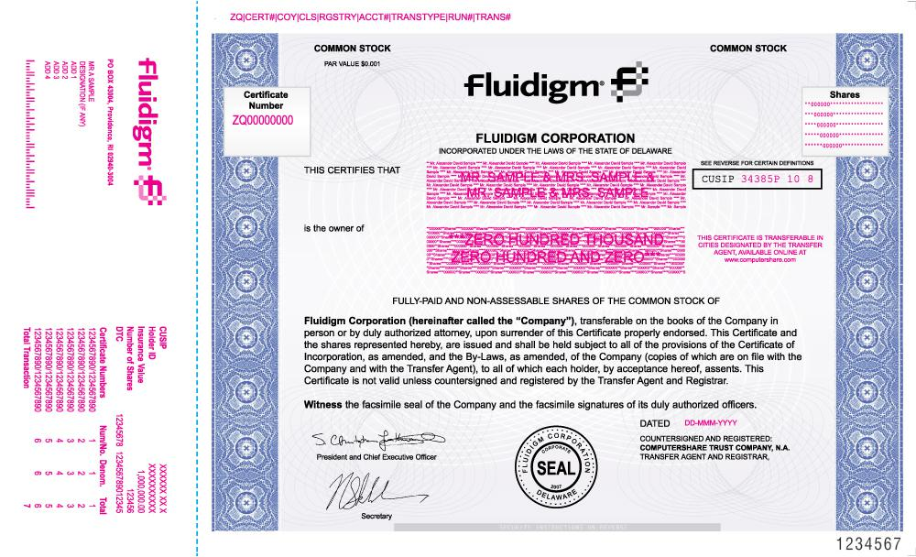

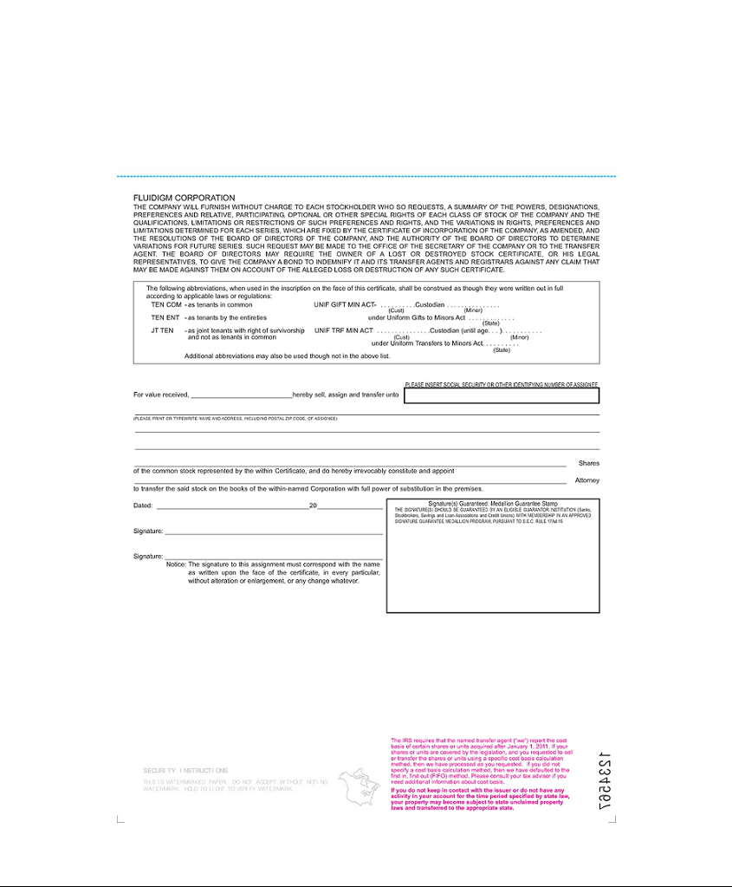

Exhibit 5.1

OPINION OF WILSON SONSINI GOODRICH & ROSATI

PROFESSIONAL CORPORATION

August 3, 2017

Fluidigm Corporation

7000 Shoreline Court, Suite 100

South San Francisco, CA 94080

Re: Registration Statement on Form S-8

Ladies and Gentlemen:

We have examined the Registration Statement on Form S-8 (the “Registration Statement”) to be filed by Fluidigm Corporation, a Delaware corporation (the “Company”), with the Securities and Exchange Commission on or about the date hereof, in connection with the registration under the Securities Act of 1933, as amended, of an aggregate of 1,000,000 shares of the Company’s common stock, par value $0.001 per share, reserved for future issuance pursuant to the Fluidigm Corporation 2017 Employee Stock Purchase Plan (the “Plan” and which shares of common stock are referred to herein as the “Shares”). As your legal counsel, we have examined the proceedings taken and are familiar with the actions proposed to be taken by you in connection with the issuance and sale of the Shares under the Plan and pursuant to the agreements related thereto. In such examination, we have assumed the following:

- the authenticity of original documents and the genuineness of all signatures; (b) the conformity to the originals of all documents submitted to us as copies; and (c) the truth, accuracy and completeness of the information, representations and warranties contained in the records, documents, instruments and certificates we have reviewed.

It is our opinion that the Shares, when issued and sold in the manner referred to in the Plan and pursuant to the agreements that accompany the Plan, will be legally and validly issued, fully paid and nonassessable.

We consent to the use of this opinion as an exhibit to the Registration Statement, and further consent to the use of our name wherever appearing in the Registration Statement and any amendments thereto.

Very truly yours,

WILSON SONSINI GOODRICH & ROSATI

Professional Corporation

/s/ Wilson Sonsini Goodrich & Rosati

Exhibit 23.1

CONSENT OF INDEPENDENT REGISTERED PUBLIC ACCOUNTING FIRM

We hereby consent to the incorporation by reference in this Registration Statement on Form S-8 of our report dated March 2, 2017 relating to the financial statements, financial statement schedule and the effectiveness of internal control over financial reporting, which appears in Fluidigm Corporation's Annual Report on Form 10-K for the year ended December 31, 2016.

/s/ PricewaterhouseCoopers LLP

San Jose, California

August 3, 2017

Exhibit 23.2

CONSENT OF INDEPENDENT REGISTERED PUBLIC ACCOUNTING FIRM

We consent to the incorporation by reference in the Registration Statement (Form S-8) for the registration of 1,000,000 shares of common stock pertaining to the Fluidigm Corporation 2017 Employee Stock Purchase Plan of our report dated February 29, 2016, with respect to the consolidated financial statements and schedule of Fluidigm Corporation included in its Annual Report (Form 10-K) for the year ended December 31, 2016, filed with the Securities and Exchange Commission.

/s/ Ernst & Young LLP

August 3, 2017

Redwood City, California

