As filed with the Securities and Exchange Commission on January 13, 2017

Registration No. 333-

UNITED STATES

SECURITIES AND EXCHANGE COMMISSION
Washington, D.C. 20549

FORM S-8

REGISTRATION STATEMENT
UNDER
THE SECURITIES ACT OF 1933

FLUIDIGM CORPORATION

(Exact name of Registrant as specified in its charter)

Delaware

77-0513190

(State or other jurisdiction of
incorporation or organization)

(I.R.S. Employer
Identification No.)

7000 Shoreline Court, Suite 100

South San Francisco, California 94080

(650) 266-6000

(Address of principal executive offices, including zip code)

Fluidigm Corporation 2011 Equity Incentive Plan

Fluidigm Corporation 2017 Inducement Award Plan

(Full title of the plan)

Stephen Christopher Linthwaite

President and Chief Executive Officer

7000 Shoreline Court, Suite 100

South San Francisco, California 94080

(650) 266-6000

(Name, address and telephone number, including area code, of agent for service)

Copies to:

Nicholas Khadder

General Counsel

7000 Shoreline Court, Suite 100

South San Francisco, California 94080

Telephone: (650) 266-6000

Robert F. Kornegay

Wilson Sonsini Goodrich & Rosati,

Professional Corporation

650 Page Mill Road

Palo Alto, California 94304

Telephone: (650) 493-9300

Indicate by check mark whether the registrant is a large accelerated filer, an accelerated filer, a non-accelerated filer, or a smaller reporting company. See the definitions of “large accelerated filer,” “accelerated filer” and “smaller reporting company” in Rule 12b-2 of the Exchange Act (Check one).

Large accelerated filer | ☐ |  |  |  |  |  | Accelerated filer |  |  | ☒
Non-accelerated filer | ☐ (Do not check if a smaller reporting company) |  |  |  |  |  | Smaller reporting company |  |  | ☐
 | CALCULATION OF REGISTRATION FEE
 |  |  |  | Amount |  | Proposed | Proposed
 | Title of Securities |  |  | Amount |  | Maximum | Maximum |  | Amount of
 |  |  |  | to be |  | Offering Price | Aggregate |  | Amount of
 | to be Registered |  |  | Registered (1) |  | Per Share | Offering Price |  | Registration Fee
Common Stock, $0.001 par value per share (including the associated
Preferred Share Purchase Rights)(2), reserved for issuance pursuant |  |  |  | 1,000,000(3) |  | $7.83(4)
to the Fluidigm Corporation 2011 Equity Incentive Plan |  |  |  | 1,000,000(3) |  | $7.83(4) | $7,830,000.00 |  | $907.50
Common Stock, $0.001 par value per share (including the associated
Preferred Share Purchase Rights)(2), reserved for issuance pursuant |  |  |  |  |  | $7.83 (4)
to the Fluidigm Corporation 2017 Inducement Award Plan |  |  |  | 2,000,000 |  | $7.83 (4) | $15,660,000.00 |  | $1,815.00
TOTAL: |  |  |  | 3,000,000 |  |  | $23,490,000.00 |  | $2,722.50

- Pursuant to Rule 416(a) of the Securities Act of 1933, as amended, this Registration Statement shall also cover any additional shares of the Registrant’s common stock that become issuable under the Fluidigm Corporation 2011 Equity Incentive Plan (the “2011 Plan”) and the Fluidigm Corporation 2017 Inducement Award Plan (the “2017 Plan”) by reason of any stock dividend, stock split, recapitalization or other similar transaction effected without receipt of consideration that increases the number of the Registrant’s outstanding shares of common stock.

- Comprised of rights to purchase shares of the Registrant’s Series A Participating Preferred Stock, par value $0.001 per share (the “Preferred Share Purchase Rights”), that are associated with shares of the Registrant’s common stock pursuant to the Tax Benefit Preservation Plan, dated as of November 21, 2016, by and between Fluidigm Corporation and Computershare Inc., as Rights Agent (the “Rights Plan”). The Preferred Share Purchase Rights are not exercisable until the occurrence of certain events specified in the Rights Plan and are transferrable solely with the associated Common Stock. The value attributed to the Preferred Share Purchase Rights, if any, is reflected in the value of the associated Common Stock.

- Represents shares of the Registrant’s common stock that were automatically added to the shares authorized for issuance under the 2011 Plan on January 1, 2017 pursuant to an “evergreen” provision contained in the 2011 Plan. Pursuant to such provision, on January 1st of each fiscal year beginning with the 2012 fiscal year, the number of shares available for issuance under the 2011 Plan is automatically increased in an amount equal to the least of (i) 1,000,000 shares of the Registrant’s common stock, (ii) four percent (4%) of the number of shares of the Registrant’s common stock outstanding on December 31st of the preceding fiscal year, or (iii) such number of shares of the Registrant’s common stock determined by the Registrant’s board of directors.

- Estimated in accordance with Rule 457(c) and (h) solely for purposes of calculating the registration fee on the basis of $7.83 per share, the average of the high and low sale prices of the Registrant’s common stock as reported on the NASDAQ Global Select Market on January 12, 2017.

FLUIDIGM CORPORATION

EXPLANATORY NOTE

This Registration Statement is filed by Fluidigm Corporation (the “Registrant”) for the purpose of registering 1,000,000 shares of common stock of the Registrant reserved for issuance under the Fluidigm Corporation 2011 Equity Incentive Plan (the “2011 Plan”) and 2,000,000 shares of common stock of the Registrant reserved for issuance under the Fluidigm Corporation 2017 Inducement Award Plan (“2017 Plan”). The shares of the Registrant’s common stock previously reserved for issuance under the 2011 Plan were registered on the following Registration Statements on Form S-8 (File Nos. 333-172206, 333-180363, 333-187204, 333-194084, 333-202325, and 333-209904, as amended) as filed with the Securities and Exchange Commission (the “Commission”) and are incorporated by reference into this Registration Statement.

PART I

INFORMATION REQUIRED IN THE PROSPECTUS

The information specified in Item 1 and Item 2 of Part I of Form S-8 is omitted from this Registration Statement on Form S-8 (the “Registration Statement”) in accordance with the provisions of Rule 428 under the Securities Act of 1933, as amended (the “Securities Act”), and the introductory note to Part I of Form S-8. The documents containing the information specified in Part I of Form S-8 has delivered or will be delivered to the participants in the equity benefit plans covered by this Registration Statement as specified by Rule 428(b)(1) under the Securities Act.

PART II

INFORMATION REQUIRED IN REGISTRATION STATEMENT

Item 3. Incorporation of Documents by Reference.

The Registrant hereby incorporates by reference into this Registration Statement the following documents previously filed with the Commission:

- The Registrant’s Annual Report on Form 10-K for the fiscal year ended December 31, 2015, filed with the Commission on February 29, 2016 and the Registrant’s Amendment No. 1 to the Registrant’s Form 10-K, filed with the Commission on April 27, 2016;

- The Registrant’s Quarterly Reports on Form 10-Q for the three months ended March 31, 2016, June 30, 2016 and September 30, 2016, filed with the Commission on May 9, 2016, August 9, 2016, and November 9, 2016, respectively;

- The Registrant’s Current Reports on Form 8-K filed with the Commission on May 23, 2016, August 4, 2016, August 4, 2016, September 13, 2016, October 24, 2016, November 22, 2016, and January 11, 2017, only to the extent that the items therein are specifically stated to be “filed” rather than “furnished” for the purposes of Section 18 of the Securities Exchange Act of 1934, as amended (the “Exchange Act”);

- The description of the Registrant’s common stock contained in the Company’s Registration Statements on Form 8-A (File No. 001-34180) filed with the Commission on February 7, 2011, pursuant to Section 12(b) of the Exchange Act, including any amendment or report filed for the purpose of updating such description; and

- The description of the Registrant’s Preferred Share Purchase Rights contained in the Company’s Registration Statements on Form 8-A (File No. 001-34180) filed with the Commission on November 22, 2016, pursuant to Section 12(b) of the Exchange Act, including any amendment or report filed for the purpose of updating such description.

All documents filed by the Registrant pursuant to Sections 13(a), 13(c), 14 and 15(d) of the Exchange Act on or after the date of this Registration Statement and prior to the filing of a post-effective amendment to this Registration Statement that indicates that all securities offered have been sold or that deregisters all securities then remaining unsold shall be deemed to be incorporated by reference in this Registration Statement and to be part hereof from the date of filing of such documents; provided, however, that documents or information deemed to have been furnished and not filed in accordance with the rules of the Commission shall not be deemed incorporated by reference into this Registration Statement. Any statement contained in a document incorporated or deemed to be incorporated by reference herein shall be deemed to be modified or superseded for purposes of this Registration Statement to the extent that a statement contained herein or in any subsequently filed document which also is deemed to be incorporated by reference herein modifies or supersedes such statement. Any such statement so modified or superseded shall not be deemed, except as so modified or superseded, to constitute a part of this Registration Statement.

Under no circumstances will any information furnished under current items 2.02 or 7.01 of Form 8-K be deemed incorporated herein by reference unless such Form 8-K expressly provides to the contrary.

Item 4. Description of Securities.

Not applicable.

Item 5. Interests of Named Experts and Counsel.

Not applicable.

Item 6. Indemnification of Directors and Officers.

Section 145 of the Delaware General Corporation Law authorizes a corporation’s board of directors to grant, and authorizes a court to award, indemnity to officers, directors, and other corporate agents.

As permitted by Section 102(b)(7) of the Delaware General Corporation Law, the Registrant’s certificate of incorporation includes provisions that eliminate the personal liability of its directors and officers for monetary damages for breach of their fiduciary duty as directors and officers.

In addition, as permitted by Section 145 of the Delaware General Corporation Law, the bylaws of the Registrant provide that:

- The Registrant shall indemnify its directors and officers for serving the Registrant in those capacities or for serving other business enterprises at the Registrant’s request, to the fullest extent permitted by Delaware law. Delaware law provides that a corporation may indemnify such person if such person acted in good faith and in a manner such person reasonably believed to be in or not opposed to the best interests of the Registrant and, with respect to any criminal proceeding, had no reasonable cause to believe such person’s conduct was unlawful.

- The Registrant may, in its discretion, indemnify employees and agents in those circumstances where indemnification is not required by law.

- The Registrant is required to advance expenses, as incurred, to its directors and officers in connection with defending a proceeding, except that such director or officer shall undertake to repay such advances if it is ultimately determined that such person is not entitled to indemnification.

- The Registrant will not be obligated pursuant to the bylaws to indemnify a person with respect to proceedings initiated by that person, except with respect to proceedings authorized by the Registrant’s board of directors or brought to enforce a right to indemnification.

- The rights conferred in the bylaws are not exclusive, and the Registrant is authorized to enter into indemnification agreements with its directors, officers, employees, and agents and to obtain insurance to indemnify such persons.

- The Registrant may not retroactively amend the bylaw provisions to reduce its indemnification obligations to directors, officers, employees, and agents.

The Registrant’s policy is to enter into separate indemnification agreements with each of its directors and officers that provide the maximum indemnity allowed to directors and executive officers by Section 145 of the Delaware General Corporation Law and also provides for certain additional procedural protections. The Registrant also maintains directors and officers insurance to insure such persons against certain liabilities.

These indemnification provisions and the indemnification agreements entered into between the Registrant and its officers and directors may be sufficiently broad to permit indemnification of the Registrant’s officers and directors for liabilities (including reimbursement of expenses incurred) arising under the Securities Act.

See also Registrant’s undertakings in Section 9 of this Registration Statement.

Item 7. Exemption from Registration Claimed.

Not applicable.

Item 8. |  | Exhibits.
 |  |  |  |  |  | Incorporated |  | Incorporated
Exhibit |  |  |  |  |  |  |  | by Reference
 |  |  |  |  |  | by Reference |  | From Exhibit
Number |  | Description |  |  |  | From Form |  | Number | Date Filed
4.1 |  | Specimen Common Stock Certificate of the Registrant. |  |  | Filed herewith.
4.2+ |  | 2017 Inducement Award Plan and related form agreements. |  |  | 8-K |  |  | 10.1 | 1/11/2017
4.3+ |  | 2011 Equity Incentive Plan of Fluidigm Corporation. |  |  | S-1/A |  |  | 10.4 | 1/28/2011
4.4+ |  | Forms of agreements under the 2011 Equity Incentive Plan. |  |  | S-1/A |  |  | 10.4A | 1/28/2011
4.5 |  | Tax Benefit Preservation Plan, dated as of November 21, 2016, by and between Fluidigm
 |  | Corporation and Computershare Inc., as Rights Agent. |  |  | 8-K |  |  | 4.1 | 11/22/2016
4.6 |  | Indenture, dated February 4, 2014, by and between Fluidigm Corporation and U.S. Bank National
 |  | Association. |  |  | 8-K |  |  | 4.1 | 2/4/2014
4.7 |  | First Supplement Indenture, dated February 4, 2014, by and between Fluidigm Corporation and
 |  | U.S. Bank National Association. |  |  | 8-K |  |  | 4.2 | 2/4/2014
4.8 |  | Form of Global Note (included in Exhibit 4.6). |  |  | 8-K |  |  | 4.3 | 2/4/2014
5.1 |  | Opinion of Wilson Sonsini Goodrich & Rosati, Professional Corporation. |  |  | Filed herewith.
23.1 |  | Consent of PricewaterhouseCoopers LLP, Independent Registered Public Accounting Firm. |  |  | Filed herewith.
23.2 |  | Consent of Ernst & Young LLP, Independent Registered Public Accounting Firm. |  |  | Filed herewith.
23.3 |  | Consent of Wilson Sonsini Goodrich & Rosati, Professional Corporation (contained in Exhibit 5.1
 |  | hereto).
24.1 |  | Power of Attorney (contained on signature page hereto).
+ Indicates management contract or compensatory plan, contract or arrangement.

Item 9. Undertakings.

A. The undersigned Registrant hereby undertakes:

- To file, during any period in which offers or sales are being made, a post-effective amendment to this Registration Statement:

  - To include any prospectus required by Section 10(a)(3) of the Securities Act of 1933;

  - To reflect in the prospectus any facts or events arising after the effective date of the registration statement (or the most recent post-effective amendment thereof) which, individually or in the aggregate, represent a fundamental change in the information set forth in the registration statement. Notwithstanding the foregoing, any increase or decrease in volume of securities offered (if the total dollar value of securities offered would not exceed that which was registered) and any deviation from the low or high end of the estimated maximum offering range may be reflected in the form of prospectus filed with the Commission pursuant to Rule 424(b) if, in the aggregate, the changes in volume and price represent no more than 20% change in the maximum aggregate offering price set forth in the “Calculation of Registration Fee” table in the effective registration statement;

  - To include any material information with respect to the plan of distribution not previously disclosed in the Registration Statement or any material change to such information in the Registration Statement.

Provided, however, that: (1) Paragraphs (A)(1)(i) and (A)(1)(ii) do not apply if the information required to be included in a post-effective amendment by those paragraphs is contained in periodic reports filed with or furnished to the Commission by the Registrant pursuant to Section 13 or Section 15(d) of the Securities Exchange Act of 1934 that are incorporated by reference in this Registration Statement.

  - That, for the purpose of determining any liability under the Securities Act of 1933, each such post-effective amendment shall be deemed to be a new registration statement relating to the securities offered herein, and the offering of such securities at that time shall be deemed to be the initial bona fide offering thereof.

  - To remove from registration by means of a post-effective amendment any of the securities being registered which remain unsold at the termination of the offering.

- The undersigned Registrant hereby undertakes that, for purposes of determining any liability under the Securities Act of 1933, each filing of the Registrant’s annual report pursuant to Section 13(a) or Section 15(d) of the Securities Exchange Act of 1934 (and, where applicable, each filing of an employee benefit plan’s annual report pursuant to Section 15(d) of the Securities Exchange Act of 1934) that is incorporated by reference in the Registration Statement shall be deemed to be a new registration statement relating to the securities offered herein, and the offering of such securities at that time shall be deemed to be the initial bona fide offering thereof.

- Insofar as indemnification for liabilities arising under the Securities Act of 1933 may be permitted to directors, officers and controlling persons of the Registrant pursuant to the foregoing provisions, or otherwise, the Registrant has been advised that in the opinion of the Securities and Exchange Commission such indemnification is against public policy as expressed in the Act and is, therefore, unenforceable. In the event that a claim for indemnification against such liabilities (other than the payment by the Registrant of expenses incurred or paid by a director, officer or controlling person of the Registrant in the successful defense of any action, suit or proceeding) is asserted by such director, officer or controlling person in connection with the securities being registered, the Registrant will, unless in the opinion of its counsel the matter has been settled by controlling precedent, submit to a court of appropriate jurisdiction the question whether such indemnification by it is against public policy as expressed in the Act and will be governed by the final adjudication of such issue.

SIGNATURES

Pursuant to the requirements of the Securities Act of 1933, the Registrant certifies that it has reasonable grounds to believe that it meets all of the requirements for filing on Form S-8 and has duly caused this Registration Statement to be signed on its behalf by the undersigned, thereunto duly authorized, in the City of South San Francisco, State of California, on January 13, 2017.

Fluidigm Corporation

By: /s/ Stephen Christopher Linthwaite

Stephen Christopher Linthwaite

President and Chief Executive Officer

POWER OF ATTORNEY

KNOW ALL PERSONS BY THESE PRESENTS, that each person whose signature appears below hereby constitutes and appoints Stephen Christopher Linthwaite and Vikram Jog, and each of them, as his or her true and lawful attorneys-in-fact and agents, with full power of substitution and resubstitution, for him or her and in his or her name, place and stead, in any and all capacities, to sign the Registration Statement on Form S-8 of Fluidigm Corporation, and any or all amendments thereto (including post-effective amendments), and to file the same, with all exhibits thereto, and other documents in connection therewith, with the Securities and Exchange Commission, granting unto said attorneys-in-fact and agents full power and authority to do and perform each and every act and thing requisite and necessary to be done in connection therewith, as fully for all intents and purposes as he might or could do in person, hereby and about the premises hereby ratifying and confirming all that said attorneys-in-fact and agent, proxy and agent, or his, her or their substitute or substitutes, may lawfully do or cause to be done by virtue hereof.

Pursuant to the requirements of the Securities Act of 1933, this Registration Statement on Form S-8 has been signed by the following persons in the capacities and on the dates indicated.

 | Signature |  |  | Title |  | Date
/s/ Stephen Christopher Linthwaite |  |  | President, Chief Executive Officer, and Director |  |  | January 13, 2017
Stephen Christopher Linthwaite |  |  | (Principal Executive Officer)
/s/ Vikram Jog |  |  | Chief Financial Officer |  |  | January 13, 2017
Vikram Jog |  |  | (Principal Financial Officer)
/s/ Jennifer Lee |  |  | Vice President, Controller |  |  | January 13, 2017
Jennifer Lee |  |  | (Principal Accounting Officer)
/s/ Samuel D. Colella |  |  | Chairman of the Board of Directors |  |  | January 13, 2017
Samuel D. Colella
/s/ Gerhard F. Burbach |  |  | Director |  |  | January 13, 2017
Gerhard F. Burbach
/s/ Evan Jones |  |  | Director |  |  | January 13, 2017
Evan Jones
/s/ Patrick S. Jones |  |  | Director |  |  | January 13, 2017
Patrick S. Jones
/s/ John A. Young |  |  | Director |  |  | January 13, 2017
John A. Young

EXHIBIT INDEX

 |  |  |  |  | Incorporated |  | Incorporated
Exhibit |  |  |  |  |  |  | by Reference
Exhibit |  |  |  |  | by Reference |  | From Exhibit
Number | Description |  |  |  | From Form |  | Number | Date Filed
4.1 | Specimen Common Stock Certificate of the Registrant. |  |  | Filed herewith.
4.2+ | 2017 Inducement Award Plan and related form agreements. |  |  | 8-K |  |  | 10.1 | 1/11/2017
4.3+ | 2011 Equity Incentive Plan of Fluidigm Corporation. |  |  | S-1/A |  |  | 10.4 | 1/28/2011
4.4+ | Forms of agreements under the 2011 Equity Incentive Plan. |  |  | S-1/A |  |  | 10.4A | 1/28/2011
4.5 | Tax Benefit Preservation Plan, dated as of November 21, 2016, by and between Fluidigm
 | Corporation and Computershare Inc., as Rights Agent. |  |  | 8-K |  |  | 4.1 | 11/22/2016
4.6 | Indenture, dated February 4, 2014, by and between Fluidigm Corporation and U.S. Bank National
 | Association. |  |  | 8-K |  |  | 4.1 | 2/4/2014
4.7 | First Supplement Indenture, dated February 4, 2014, by and between Fluidigm Corporation and
 | U.S. Bank National Association. |  |  | 8-K |  |  | 4.2 | 2/4/2014
4.8 | Form of Global Note (included in Exhibit 4.3). |  |  | 8-K |  |  | 4.3 | 2/4/2014
5.1 | Opinion of Wilson Sonsini Goodrich & Rosati, Professional Corporation. |  |  | Filed herewith.
23.1 | Consent of PricewaterhouseCoopers LLP, Independent Registered Public Accounting Firm. |  |  | Filed herewith.
23.2 | Consent of Ernst & Young LLP, Independent Registered Public Accounting Firm. |  |  | Filed herewith.
23.3 | Consent of Wilson Sonsini Goodrich & Rosati, Professional Corporation (contained in Exhibit 5.1
 | hereto).
24.1 | Power of Attorney (contained on signature page hereto).

+ Indicates management contract or compensatory plan, contract or arrangement.

Exhibit 4.1
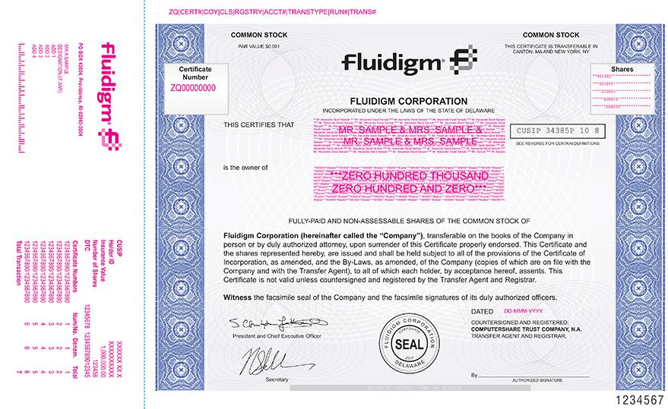

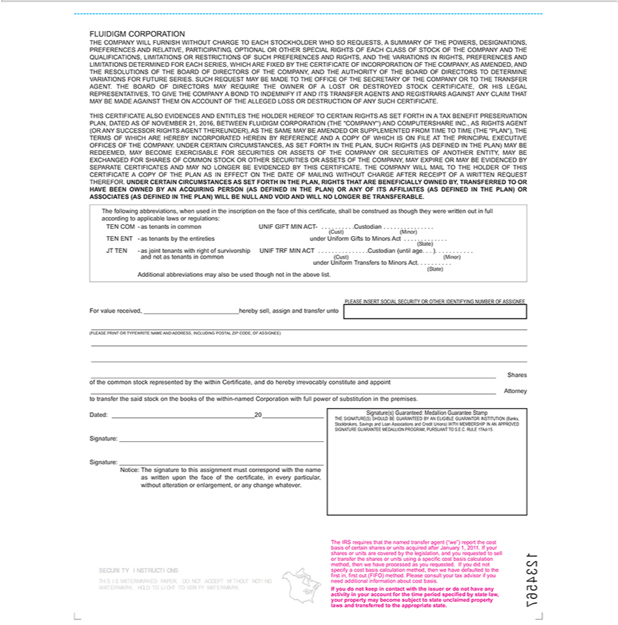

Exhibit 5.1

OPINION OF WILSON SONSINI GOODRICH & ROSATI

PROFESSIONAL CORPORATION

January 13, 2017

Fluidigm Corporation

7000 Shoreline Court, Suite 100

South San Francisco, CA 94080

Re: Registration Statement on Form S-8

Ladies and Gentlemen:

We have examined the Registration Statement on Form S-8 (the “Registration Statement”) to be filed by Fluidigm Corporation, a Delaware corporation (the “Company”), with the Securities and Exchange Commission on or about the date hereof, in connection with the registration under the Securities Act of 1933, as amended, of an aggregate of 3,000,000 shares of the Company’s common stock, par value $0.001 per share, consisting of: (i) 1,000,000 additional shares of common stock reserved for future issuance pursuant to the Fluidigm Corporation 2011 Equity Incentive Plan; and (ii) 2,000,000 shares of common stock reserved for future issuance pursuant to the Fluidigm Corporation 2017 Inducement Award Plan (which plans are referred to herein as the “Plans” and which shares of Common Stock are referred to herein as the “Shares”) and preferred share purchase rights (the “Rights”) associated with the shares of common stock issuable upon exercise of the Shares to be issued pursuant to that certain Tax Benefit Preservation Plan, dated as of November 21, 2016, by and between the Company and Computershare Inc., as Rights Agent. As your legal counsel, we have examined the proceedings taken and are familiar with the actions proposed to be taken by you in connection with the issuance and sale of the Shares under the Plans and pursuant to the agreements related thereto. In such examination, we have assumed the following: (a) the authenticity of original documents and the genuineness of all signatures; (b) the conformity to the originals of all documents submitted to us as copies; and (c) the truth, accuracy and completeness of the information, representations and warranties contained in the records, documents, instruments and certificates we have reviewed.

It is our opinion that the Shares, when issued and sold in the manner referred to in the Plans and pursuant to the agreements that accompany the Plans, will be legally and validly issued, fully paid and nonassessable.

We consent to the use of this opinion as an exhibit to the Registration Statement, and further consent to the use of our name wherever appearing in the Registration Statement and any amendments thereto.

Very truly yours,

WILSON SONSINI GOODRICH & ROSATI

Professional Corporation

/s/ Wilson Sonsini Goodrich & Rosati

Exhibit 23.1

CONSENT OF INDEPENDENT REGISTERED PUBLIC ACCOUNTING FIRM

We hereby consent to the incorporation by reference in this Registration Statement on Form S-8 of our report dated February 29, 2016, relating to the financial statements, financial statement schedule, and the effectiveness of internal control over financial reporting, which appears in Fluidigm Corporation’s Annual Report on Form 10-K for the year ended December 31, 2015.

/s/ PricewaterhouseCoopers LLP

San Jose, California

January 13, 2017

Exhibit 23.2

CONSENT OF INDEPENDENT REGISTERED PUBLIC ACCOUNTING FIRM

We consent to the incorporation by reference in the Registration Statement (Form S-8) for the registration of 1,000,000 shares of common stock pertaining to the Fluidigm Corporation 2011 Equity Incentive Plan and 2,000,000 shares of common stock pertaining to the Fluidigm Corporation 2017 Inducement Award Plan of our report dated February 29, 2016, with respect to the consolidated financial statements and schedule of Fluidigm Corporation included in its Annual Report (Form 10-K) for the year ended December 31, 2015, filed with the Securities and Exchange Commission.

/s/ Ernst & Young LLP

January 13, 2017

Redwood City, California

