SEC Form 4

FORM 4

Check this box if no longer subject to Section
- Form 4 or Form 5 obligations may continue. See Instruction 1(b).

UNITED STATES SECURITIES AND EXCHANGE COMMISSION
Washington, D.C. 20549
Washington, D.C. 20549 |  | OMB APPROVAL
STATEMENT OF CHANGES IN BENEFICIAL OWNERSHIP
STATEMENT OF CHANGES IN BENEFICIAL OWNERSHIP |  | OMB Number: | 3235-0287
 |  | Estimated average burden
Filed pursuant to Section 16(a) of the Securities Exchange Act of 1934 |  | hours per response: | 0.5
or Section 30(h) of the Investment Company Act of 1940
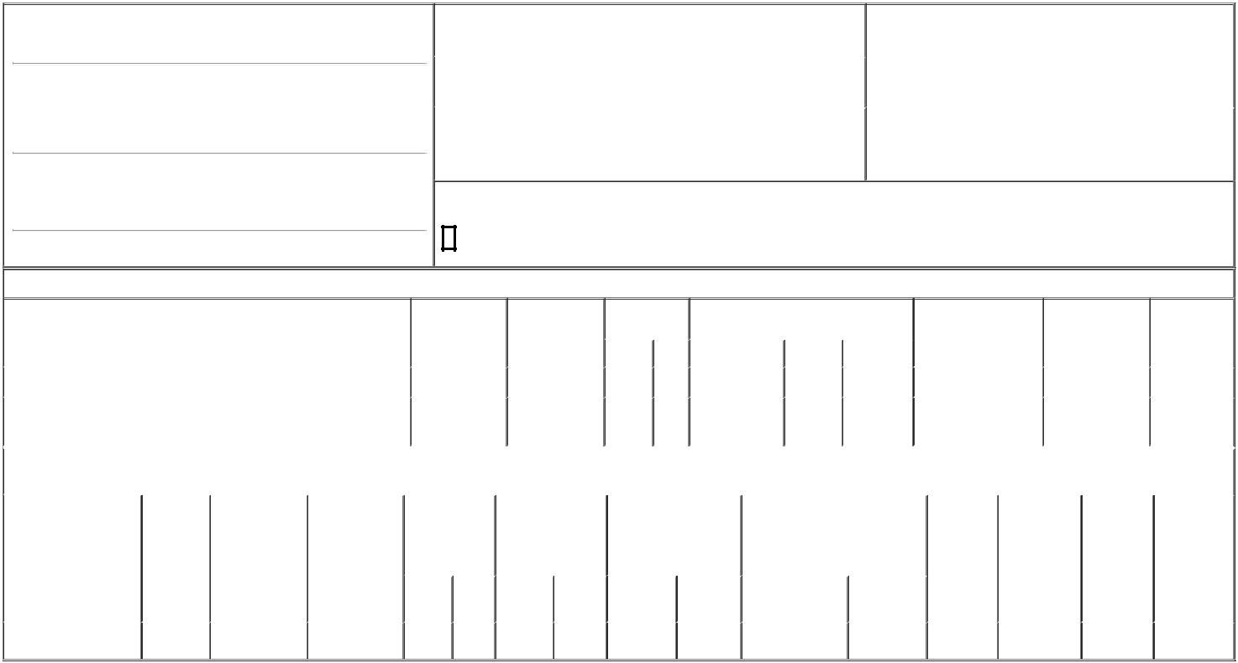

1. Name and Address of Reporting Person*
Witney Frank

(Last) | (First) | (Middle)
C/O STANDARD BIOTOOLS INC.
2 TOWER PLACE, STE 2000
(Street)
SOUTH SAN | CA | 94080
FRANCISCO | CA | 94080
(City) | (State) | (Zip)

2. |  | Issuer Name and Ticker or Trading Symbol |  | 5. Relationship of Reporting Person(s) to Issuer
 | STANDARD BIOTOOLS INC. [ LAB ] |  |  | (Check all applicable)
 |  |  |  | X | Director | 10% Owner
3. |  | Date of Earliest Transaction (Month/Day/Year) |  |  | Officer (give title | Other (specify below)
06/14/2023 |  |  |  |  | below) | Other (specify below)
4. |  | If Amendment, Date of Original Filed (Month/Day/Year) |  | 6. Individual or Joint/Group Filing (Check Applicable Line)
 |  |  |  | X | Form filed by One Reporting Person
 |  |  |  |  | Form filed by More than One Reporting Person

Rule 10b5-1(c) Transaction Indication

Check this box to indicate that a transaction was made pursuant to a contract, instruction or written plan that is intended to satisfy the affirmative defense conditions of Rule 10b5-1(c). See Instruction 10.

Table I - Non-Derivative Securities Acquired, Disposed of, or Beneficially Owned

 | 1. Title of Security (Instr. 3) |  |  |  | 2. Transaction |  | 2A. Deemed |  | 3. Transaction |  | 4. Securities Acquired (A) or Disposed Of |  |  |  | 5. Amount of Securities |  |  | 6. Ownership |  | 7. Nature of
 |  |  |  |  | Date |  | Execution Date, |  | Code (Instr. 8) (D) (Instr. 3, 4 and 5) |  |  |  |  |  | Beneficially Owned |  |  | Form: Direct (D) or |  | Indirect
 |  |  |  |  | (Month/Day/Year) |  | if any |  |  |  |  |  |  |  | Following Reported |  |  | Indirect (I) (Instr. 4) |  | Beneficial
 |  |  |  |  |  |  | (Month/Day/Year) |  | Code | V | Amount |  | (A) or (D) | Price | Transaction(s) (Instr. 3 |  |  |  |  | Ownership
 |  |  |  |  |  |  |  |  | Code | V | Amount |  | (A) or (D) | Price | and 4) |  |  |  |  | (Instr. 4)
 | Common Stock |  |  |  | 06/14/2023 |  |  |  | A |  | 26,376⁽¹⁾ |  | A | $0 | 73,142 |  |  |  | D
 | Common Stock |  |  |  |  |  |  |  |  |  |  |  |  |  | 4,225 |  |  |  | I | See
 | Common Stock |  |  |  |  |  |  |  |  |  |  |  |  |  |  |  |  |  | I | footnote⁽²⁾
 |  |  |  | Table II - Derivative Securities Acquired, Disposed of, or Beneficially Owned
 |  |  |  |  | (e.g., puts, calls, warrants, options, convertible securities)
 | 1. Title of Derivative | 2. | 3. Transaction | 3A. Deemed | 4. Transaction |  | 5. Number of |  | 6. Date Exercisable and |  |  | 7. Title and Amount of Securities |  |  |  | 8. Price of | 9. Number of |  | 10. | 11. Nature of
 | Security (Instr. 3) | Conversion | Date | Execution Date, | Code (Instr. 8) |  | Derivative |  | Expiration Date |  |  | Underlying Derivative Security |  |  |  | Derivative | derivative |  | Ownership | Indirect
 |  | or Exercise | (Month/Day/Year) | if any |  |  | Securities Acquired |  | (Month/Day/Year) |  |  | (Instr. 3 and 4) |  |  |  | Security | Securities |  | Form: | Beneficial
 |  | Price of |  | (Month/Day/Year) |  |  | (A) or Disposed of |  |  |  |  |  |  |  |  | (Instr. 5) | Beneficially |  | Direct (D) or | Ownership
 |  | Derivative |  |  |  |  | (D) (Instr. 3, 4 and |  |  |  |  |  |  |  |  |  | Owned |  | Indirect (I) | (Instr. 4)
 |  | Security |  |  |  |  | 5) |  |  |  |  |  |  |  |  |  | Following |  | (Instr. 4)
 |  |  |  |  |  |  |  |  |  |  |  |  |  |  |  |  | Reported
 |  |  |  |  |  |  |  |  |  |  |  |  |  | Amount or |  |  | Transaction(s)
 |  |  |  |  |  |  |  |  | Date |  | Expiration |  |  | Number of |  |  | (Instr. 4)
 |  |  |  |  | Code | V | (A) | (D) | Exercisable |  | Date | Title |  | Shares
 | Stock Option (Right to | $2.18 | 06/14/2023 |  | A |  | 35,380 |  | (3) |  | 06/14/2033 | Common Stock |  | 35,380 | $0 |  | 35,380 |  | D
 | Buy) | $2.18 | 06/14/2023 |  | A |  | 35,380 |  | (3)

Explanation of Responses:

- Consists of Restricted Stock Units. Each Restricted Stock Unit represents the right to receive one share of common stock upon vesting. The Restricted Stock Units vest in full on the earlier to occur of June 14, 2024 and one day prior to the date of the Company's next annual meeting of stockholders subject to the Reporting Person's continued service through the applicable vesting date.

- Shares held indirectly by First Amended and Restated Revocable Trust Agreement For The Franklin R. Witney and Catherine J. Caulfield-Witney Trust Agreement Dated September 25, 2009 (dated July 31, 2018).

- The Option becomes exercisable in twelve equal monthly increments beginning on July 14, 2023 subject to the Reporting Person's continued service through the applicable vesting date.

Remarks:

Exhibit 24.1 - Power of Attorney

 | /s/ Frank Witney by Agnieszka |  | 06/16/2023
 | Gallagher, Attorney-in-Fact
 | ** Signature of Reporting Person |  | Date
Reminder: Report on a separate line for each class of securities beneficially owned directly or indirectly.
* If the form is filed by more than one reporting person, see Instruction 4 (b)(v).
** Intentional misstatements or omissions of facts constitute Federal Criminal Violations See 18 U.S.C. 1001 and 15 U.S.C. 78ff(a).
Note: File three copies of this Form, one of which must be manually signed. If space is insufficient, see Instruction 6 for procedure.
Persons who respond to the collection of information contained in this form are not required to respond unless the form displays a currently valid OMB Number.



